MODELLING AND EXPERIMENTAL SURVEY ON GROUND BORNE VIBRATION INDUCED BY RAIL TRAFFIC
Di Mino G.
Associate Professor – University of Palermo – dimino@ing.unipa.it
Di Liberto C. M.
Ph. D. – University of Palermo – diliberto@ing.unipa.it

ABSTRACT
The ground borne vibrations, induced by the passage of trains, can propagate to the foundations of surrounding buildings.
This phenomenon can be dangerous when the railway passes through a town or near built-up areas.
Therefore the suitable numerical models for assessment the values of ground borne vibrations come in handy especially to the railway designers.
In this paper it was developed a 3D FEM model of rail track-ground system, that takes into account the train characteristics, the type of rail track, the shape of rail cross-section (tunnel, embankment, cutting), the ground mechanical characteristics, the soil stratigraphy, the foundation type of surrounding buildings and the train speed.
On the basis of an experimental survey carried out along the Marsala-Alcamo railway, the measured outputs, in terms of acceleration of the points of system, and the results, coming from the 3D FEM model, were compared.
The 3D FEM model results agree with the measured results. Hence the proposed model has been validated.

Keywords: traffic induced vibrations, train-railtrack-ground interaction, 3D FEM modelling.

INTRODUCTION
In many medium and large Italian cities, traditional railway transport is combined with and sometimes even substitutes light rail for mass transit. Use of this means of transport has brings obvious economic and environmental advantages but some important technical problems have also been associated.
One of the problems that deserves special attention is the phenomenon of the “generation” and the “propagation” of vibration actions generated by wheel-rail contact, which are propagated into the surrounded space, creating an impact on a variety of sensitive receptors.
It therefore appears important, already at the project phase, to put every effort into understanding and resolving the problem, using forecast models and methods of calculation which may also be heterogeneous, that can adequately represent the individual processes of generation and propagation of the vibrational waves while identifying a single logical process for resolving the problem.
In this study, we have developed a method for analysing ground borne vibrations from railway track, which allows use of the “integrated dynamic analysis” of the trinomial train-railtrack-ground, taking into account important aspects such as the train speed, the type of rail cross-section (tunnel, embankment, cutting), the ground mechanical characteristics, the soil stratigraphy and the foundation types of surrounding buildings.
We also carried out an in situ experiment that consists of a series of acceleration measurements of the rail track and the surrounding ground. The experiment was conducted on the Alcamo-Marsala railway line and aimed at obtaining useful data for the calibration and subsequent validation of the proposed method of analysis.

MODELLING OF THE TRAIN–RAIL TRACK–GROUND SYSTEM
An organic analysis of the problem needs to take into account the phenomena linked to the generation of dynamic actions caused by wheel–rail contact, evaluating reciprocal interactions between train and rail track. This analysis also needs to take into account the propagation phenomena of these actions, from rail track to surrounding ground, and hence to adjacent structures.
In this sense, the proposed methodology (Fig. 1) in this study is based on the creation of two models listed as follows:
- the 2D model with parameters focussing on train-rail track interaction; the problem of generation of vibrations is tackled through this model;
- the 3D FEM model for rail track-ground interaction, which allows the quantifying of the impact of vibrations caused by railway activity on the surrounding environment, especially at certain points in the ground mass situated next to the track.
The 2D model of concentrated parameters takes the vertical irregularity of the rail-track into account, and allows calculation of the time history of wheel-rail contact forces, which is later used as a causal element in the 3D FEM model.
3D FEM MODEL FOR RAIL TRACK-GROUND INTERACTION
MECHANICAL RESPONSE
GENERATION OF IRREGULARITY
WHEEL-RAIL
CONTACT FORCES
2D MODEL FOR TRAIN-RAIL TRACK INTERACTION
PROPOSED ANALYSIS PROCEDURE
Figure 1 – Flow chart showing calculation procedure

2D model for train-rail track interaction
In order to calculate train-rail track interaction (which is calculated in terms of wheel-rail contact force), a model allowing the study of the vertical dynamics of the two subsystems train-rail track was developed (Fig.2).
The train was modelled with a lumped mass system with 10 degrees of freedom:
- vertical displacement (Z_{c}) and pitching rotation (ϕ_{c}) of the wheel set;
- vertical displacement (Z_{ti} for i=1,2) and pitching rotation (ϕ_{c} for i=1,2) of bogies;
- vertical displacement of the wheels (Z_{w})
The primary suspension (K_{s1}, C_{s1}) and the secondary suspension (K_{s2}, C_{s2}) were modelled using springs and dashpots.
For the rail-track, a model of finite length with rail on discrete support, with three levels of elasticity was used (Sato et al. 1987, Zhai 1992). The rail, modelled as a Bernoulli continuous beam, is considered connected, with periodicity equal to the distance between the sleepers, to a series of spring-damping elements (K_{p}, C_{p}) which reproduce the dynamic behaviour of the fastening system. These elements represent the first level of elasticity and are connected to the concentrated masses M_{s} representing the vertical inertia of the sleepers. The inertial behaviour of the ballast portions beneath each sleeper is modelled with the masses M_{b}; consequently the second level of elasticity is obtained by interjecting a series of spring-damping elements (K_{b}, C_{b}) arranged vertically between the concentrated masses M_{s} and M_{b}.
Also, in order to simulate the shear behaviour of the ballast, each mass M_{b} is connected elastically (K_{w}, C_{w}) to the next.

Figure 2 – Flat model for train-rail track interaction

The third level of elasticity is made up of the elements K_{f}-C_{f,} which are attached above to the ballast elements and below to a rigid boundary, modelling the mechanical behaviour of the subgrade.
A modal approach was used to write the equations of equilibrium of the rail: the vertical deformed shape of the rail is obtained through the following relation

$Z_{r}\left(\text{x,t}\right)=\sum_{k=1}^{N}{Y_{k}\left(x\right)⋅q_{k}\left(t\right)}$, (Eq.1)
in which:
- Y_{k}(x) is the rail mode shape function associated to the k mode shapes of the beam structure;
- q_{k}(t) is the k modal coordinate;
- N is the total number of mode shapes considered in the rail.
Thus, reformulating the dynamic equation of the rail in the modal space, we obtain a system of differential equations in the N unknown quantities q_{k}(t), which are taken as degrees of freedom of the rail. Naturally, the higher the number N of modal shapes considered, the more accurate the solution will be.
Train-rail track interaction takes place through the “wheel-rail contact force”, which can be calculated using the Hertzian theory. The contact force corresponding to the i^{th} wheel is obtained through the relation:

$P_{\text{wr}}(t)=C_{H}⋅{\left\{Z_{w}(t)−Z_{r}(\text{x,t})−Z_{0}(\text{Vt})\right\}}^{\text{3/2}}$ (Eq. 2)

where:
- C_{H} is the Hertzian wheel-rail contact coefficient;
- Z₀(t), is the function that expresses the irregularities of the rail track through a given speed of the train (t=s/v).
The term $Z_{w}(t)−Z_{r}(\text{x,t})−Z_{0}(\text{Vt})$ represents the instant vertical deformation of the wheel-rail point of contact.
By assembling the dynamic equations of the train and the rail track into a single relation, the global equilibrium equation of the train-rail track system is obtained:

$\underline{\underline{M}}\underline{\overset{¨}{Z}}+\underline{\underline{C}}\underline{\overset{˙}{Z}}+\underline{\underline{K}}\underline{Z}=\underline{F}({\text{t,Z}}_{w},Z_{r},Z_{0})$, (Eq. 3)

where $\underline{Z}$, $\underline{\overset{˙}{Z}}$ and $\underline{\overset{¨}{Z}}$ being the generalised vectors of displacement, the speed and the acceleration, $\underline{F}$ is the vector of the external forces, and finally $\underline{\underline{M}}$, $\underline{\underline{K}}$, $\underline{\underline{C}}$ are the matrices of mass, stiffness and damping of the system.
The response of the rail track-ground system is obtained through the implicit step by step integration of equation 3.
The maintenance state of the rail track is considered by including the profile of vertical irregularity in equation 2 which, being a stationary ergodic Gaussian random process, was generated with the Monte Carlo method, note the relative power spectral density (Panagin R. 1990, Roberts B.J. et al. 1990)

3D FEM Model for rail track-ground interaction
The model developed in the previous paragraph enables to deal with the problem of train-rail track interaction satisfactorily, but it fails to determine how the stress originating from wheel-rail contact propagates to the supporting ground and thus, to the surrounding areas (the subgrade is represented by the 3rd level of elasticity).
An analysis methodology is therefore proposed. This consists in the implementation of a tridimensional model of the finite elements, able to simulate the behaviour of the rail track-ground system in adequate detail. (Di Mino et al. 2007).
Regarding the rail track typology under consideration (ballasted rail track), the main components of the system are:
- the rail;
- the fastening system;
- the sleeper;
- the ballast;
- the ground.
A diagram of the FEM model used for the track can be seen in figure 3. The particular geometrical and mechanical symmetry in relation to the vertical plane that crosses the axis of the track, allow the modelling of half of the system; symmetrical constraints were therefore applied down the centre of the sleepers.
The rail and the sleeper were designed as mono-dimensional Bernoulli elements. Beam elements with two nodes of 13 cm were used for the sleeper. As far as the rail is concerned, also modelled with beam elements with two nodes, the dimension of the element turns out to be one of the most important parameters for the successful working of the model, since the maximum frequency of the dynamic stress that the model is able to reproduce depends on the given transit speed of the train. (paragraph 2.2.1.)
The fastening system was modelled through the introduction of the spring-damping elements, arranged vertically, between the rail nodes and the respective nodes that belong to the underlying sleeper elements.

Figure 3 – FEM model of rail track

The ballast and the ground were modelled by meshing the relative geometrical area with 4 node three-dimensional elements and by giving the materials a viscous elastic characteristic.
The damping behaviour of each basic component j of the railtrack-ground system was modelled with the Rayleigh methodology.
The damping matrix ${\underline{\underline{C}}}_{j}$ can be obtained from the relation

${\underline{\underline{C}}}_{j}=α_{j}{\underline{\underline{M}}}_{j}+β_{j}{\underline{\underline{K}}}_{j}$ , (Eq. 4)

where ${\underline{\underline{M}}}_{j}$ is the mass matrix, and ${\underline{\underline{K}}}_{j}$ the stiffness matrix.
Determination of the parameters α_{j} and β_{j} was carried out using the procedure described by Di Mino et al. (2007). The same applies to the characterisation of the mesh and the application of the boundary conditions.
Applying the modelling procedure to the stretch in question in the experimental activity, and since the stratigraphy of the site is constituted by a compact calcarenite mass with the value V_{s} = 700 m/sec, the maximum dimension to be given to the ground elements is equal to 1,16 m.
The mesh was made as follows:
- in the part of the model where the result of the system was calculated, corresponding to a strip of about 30m from the rail (20 m deep), elements of a maximum dimension of 0.6m were used;
- outside the above-mentioned area, the dimensions were gradually modified up to 3 m, corresponding to the boundary.
The meshing of the field in the areas directly behind the source (rail) foresees dimensions of the ballast elements of between 13 and 16 cm, going from the wall plate of the sleeper to the support plate of the same ballast, while the dimension of the ground elements increases gradually from 16 to 60 cm as one moves away from the track.

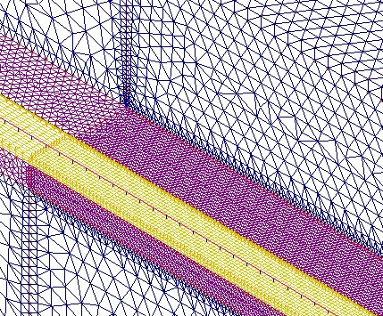
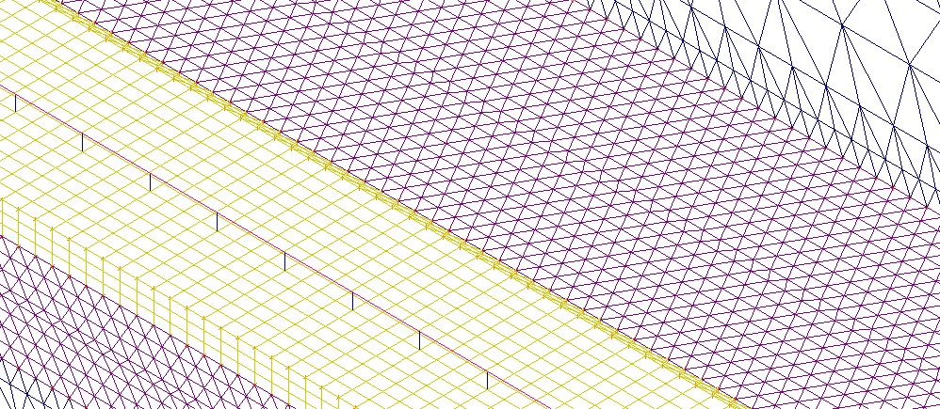
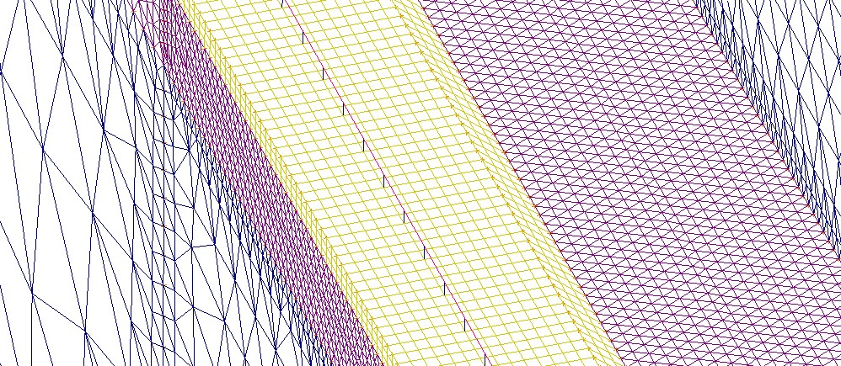
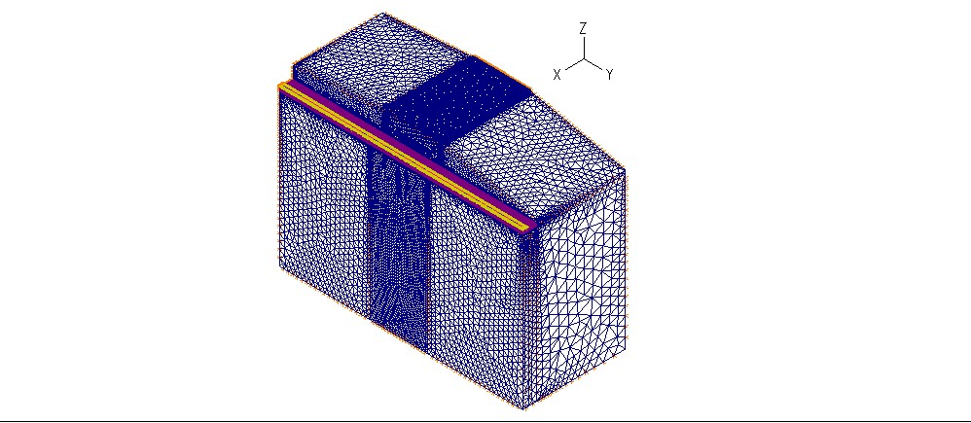
46,2 m
81,9 m
51,3 m

Figure 4 – Mesh of the 3D FEM model

The mesh model represented in figure 4 above indicates the dimensions assigned to the model.

The excitation model
The excitation of the rail track-ground model was implemented simulating the train-rail track interaction and calculating the dynamic effects.
In technical literature, it is possible to find different excitation models related to the techniques of resolution used or to analysis purposes (Knothe KL. et al. 1993). In the analysis procedure hereby proposed, the train-rail track interaction was implemented with the “moving load model”, considering a moving load sequence travelling on the rail at a constant speed V.
At each node of the rail, a vertical, impulsive force of set finite range (t_{n}-t_{n-1}) and intensity was applied; the transit effect of the rail force is obtained by staggering appropriately in the course of time the application of the force on the contiguous nodes (Fig. 5). To make this possible, it is necessary to provide a temporal step of integration equal to (t_{n}-t_{n-1})/2.

Figure 5 – Loading functions on rail nodes

The time range of the impulse t_{n}-t_{n-1} must be enough to give sufficiently wide frequency to the dynamic force.
In order to allow the dynamic force to be representative in the frequency range 0-600 Hz in the applications developed in the present study, it was necessary to set Δt=0.0008125 sec. So, once the transit speed of the train was known, the dimension to be given to each beam element of the rail remained to be clearly determined. In fact, travelling at speed V, to allow use of the load model as described above, the distance between the nodes must be equal to the distance covered by the vehicle in the interval of time Δt.
For example, where V = 25 m/sec and Δt = 0.0008125 sec, the distance between the nodes is Δx = 0,0203125 m.
Once the train speed, the distance of wheelsets and the distance between the rail nodes were noted, we set the time functions to the nodes in order to simulate the passage of the train wheel.
The intensity of the impulsive loads was determined by the model for train-rail track interaction as described in paragraph 2.1 (Fig.2). Once the time history of the wheel-rail contact forces was calculated, an intensity equal to the value adopted by the same contact force P_{wj}(t) when the j-th wheel is in correspondence with node n, was given to function f_{n}(t).
It is necessary to clarify that the procedure of integration at equation 3 required a smaller time interval of integration Δt than the interval Δt used for the integration of the equations of the FEM model. The choice of this interval was due to Δt/Δt resulting in a integer n, therefore by sampling P_{wj}(t) with a step equal to n×Δt, we obtained the values of contact force to be given to the functions f_{n}(t).
In the case of the developed applications, it was confirmed that a value of n = 16, or Δt = 5,078125×10⁻⁵ sec allowed the convergence of the procedure of integration of the 2D train-rail track interaction model.

THE EXPERIMENTAL INVESTIGATION
The experimental survey involved a series of acceleration measurements carried out on the Alcamo-Marsala line at 116km, with the aim of obtaining useful information for the calibration and eventual validation of the proposed analytical method.
The site is located in the outskirts of the town of Castelvetrano, about 2 km from the railway station, and is characterised by a cross section in a 7 m deep cutting, along the whole segment with a base width of 9 m and an embankment geometry of which is prevalently vertical (Fig. 6).
The cutting lies within a compact calcarenite mass, while the rail track in the site is traditional and made up of the following elements:
- rail, type 50 UIC;
- FS oak sleeper, measuring 26x14x250 cm, with a sleeper spacing of 65 cm;
- K-fasteners with rubber-cork pad;
- ballast, 50 cm thick, as outlined in RFI technical specifications.

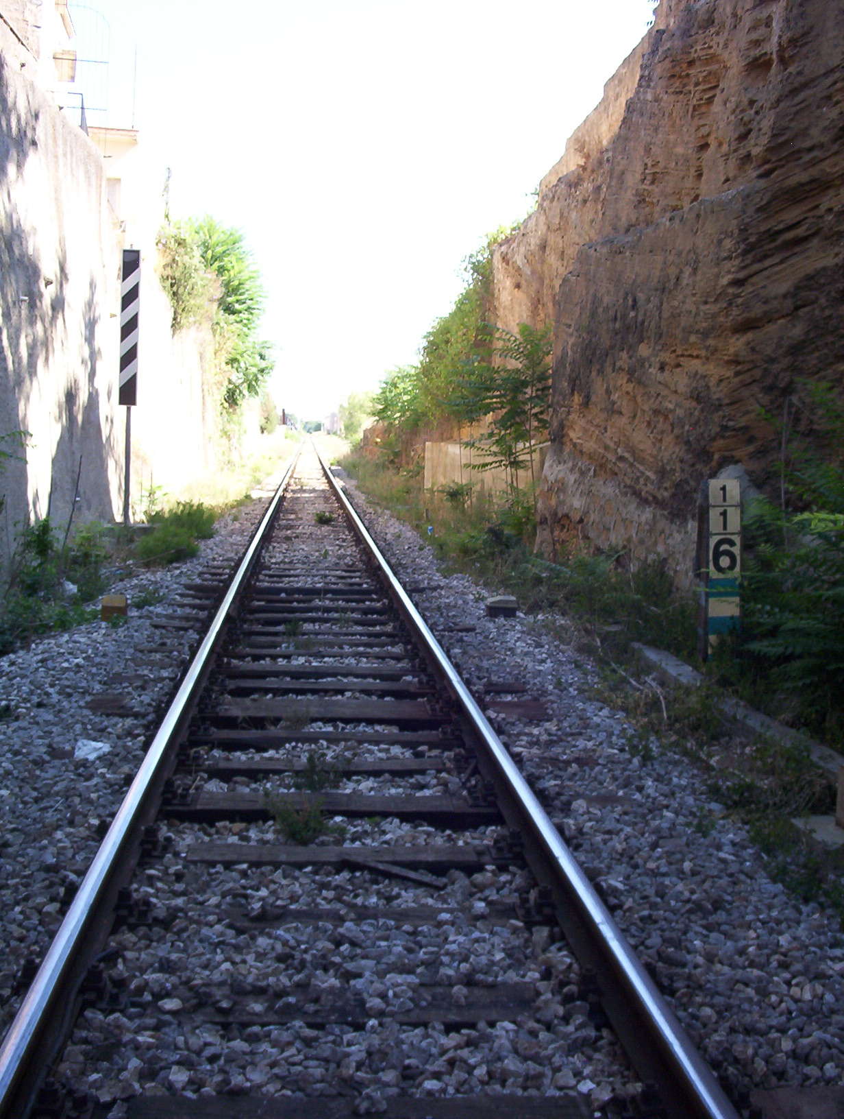
a) b)
Figure 6 - The Alcamo-Marsala line, km 116: a) photo of the analysed segment; b) cross section showing measurement points

The line is mostly used for medium and long-distance passenger transfer. The types of train used on the stretch of track in question are two: type ALn 668.3000 and the more recent Minuetto DMU.
On site, an acceleration survey was carried out, by measuring accelerations produced by passing trains as they occur at 4 characteristic points, situated respectively on the rail (P₁), on the sleeper (P₂), on the ground near the track (P₃) and on the country-side plan (P₄), as shown in figure 6-b.

Figure 7 - Diagram of series of measurement

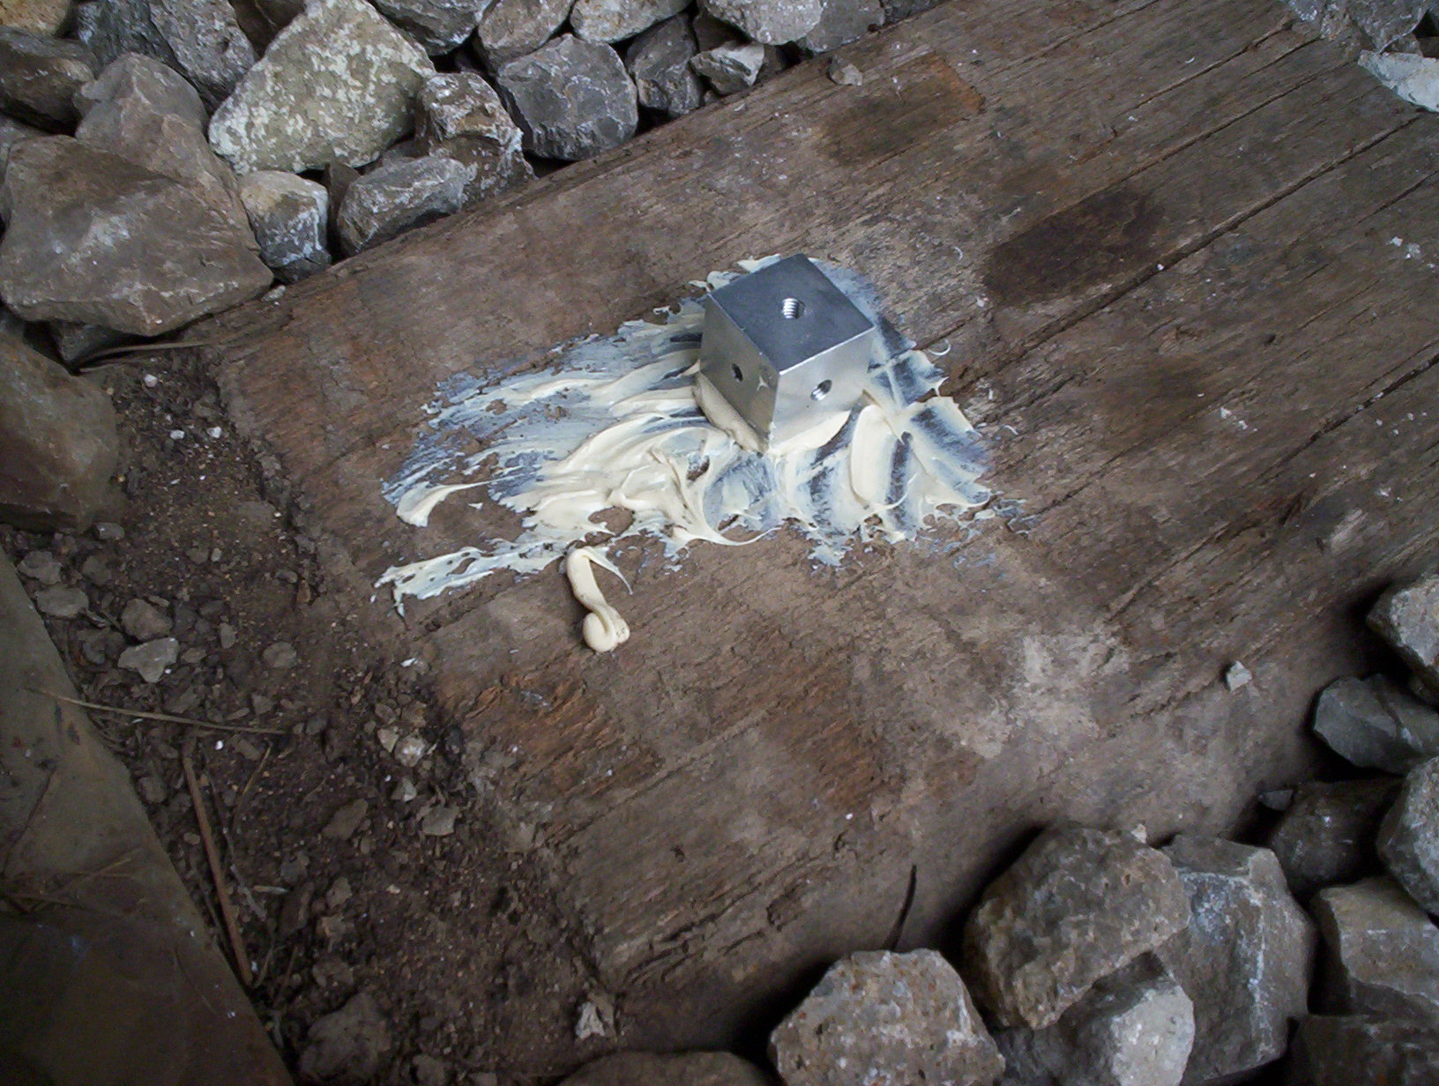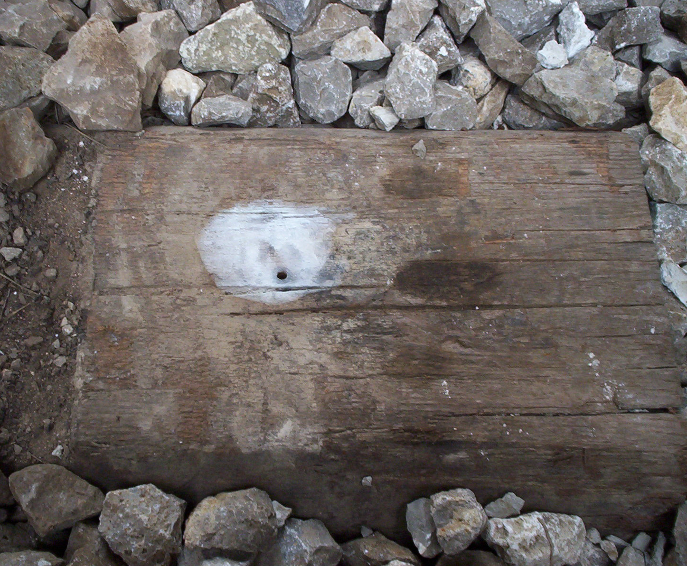
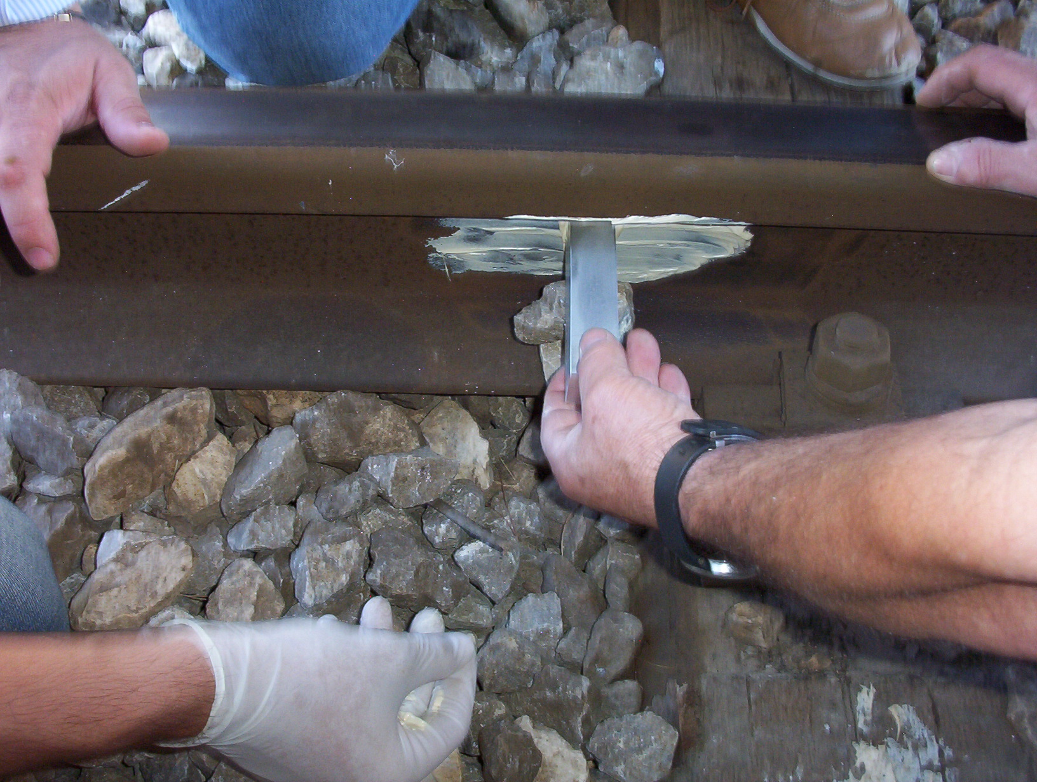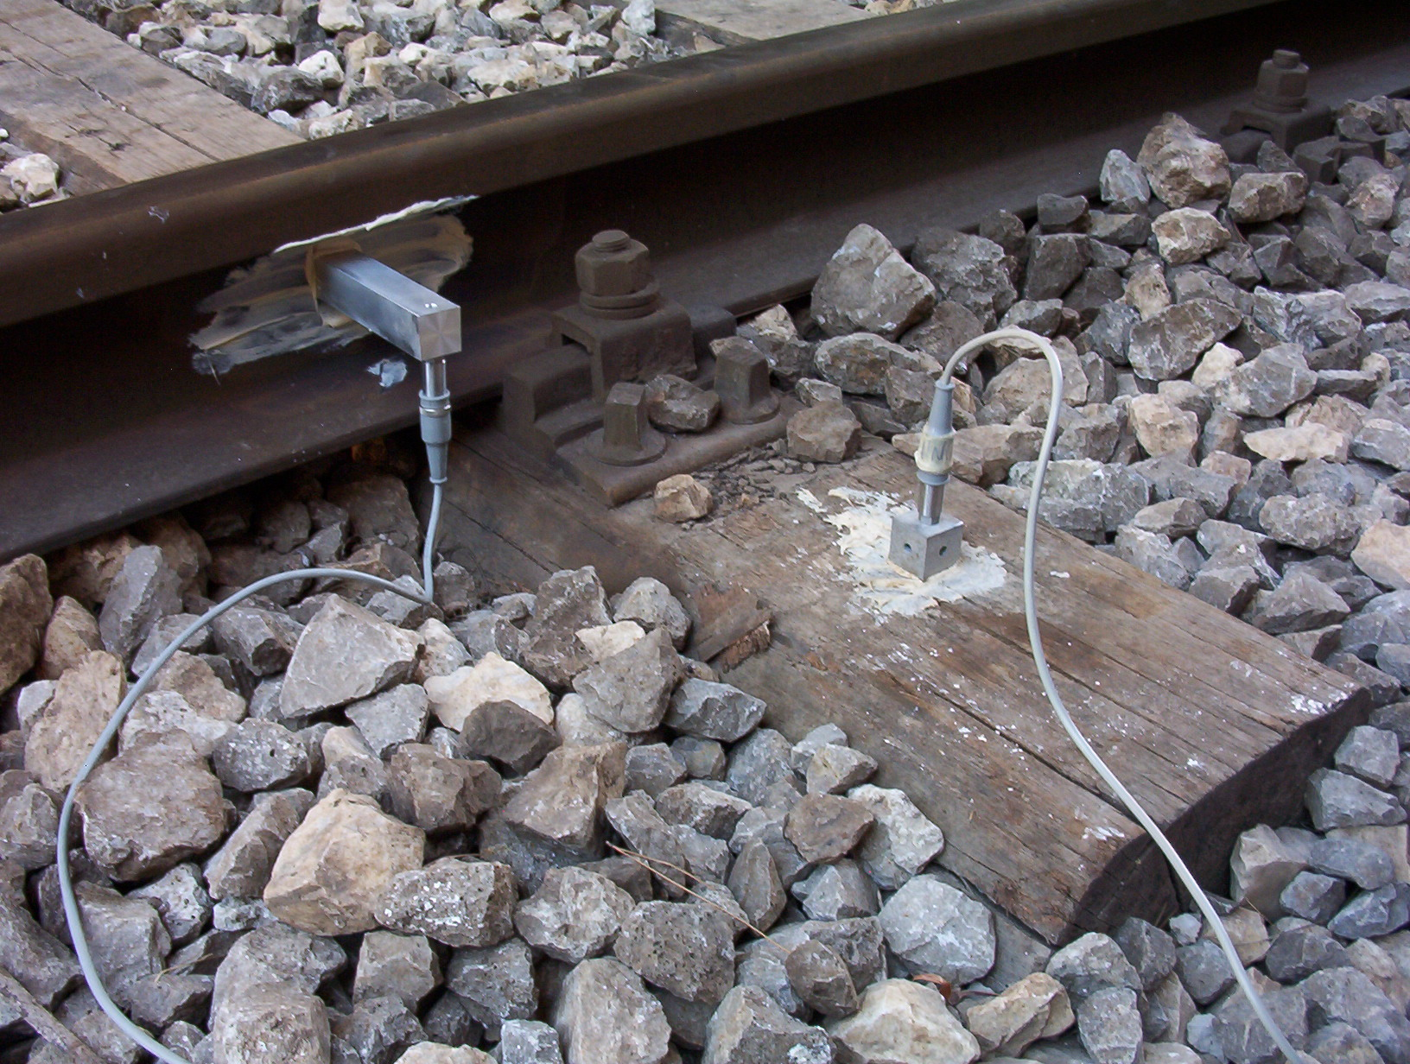
Figure 8 - Phases in setting up acceleration transducers on the rail and sleeper

At the rail and sleeper points vertical acceleration was measured (z direction), while at the ground point P₄, accelerations that were transverse and longitudinal to the railway axis were measured (x and y directions). Finally, at ground point P₃, readings were taken in the 3 directions x, y and z.
The instruments used consisted in the following:
- inductive HBM acceleration transducers;
- connecting cables;
- E.C.U. to supply acceleration transducers (HBM DMC 9012A);
- E.C.U. to gather data (NI PCI 4472);
- electronic calculator (PC PIV 3GHz, 1GB RAM, Win XP).
Inductive HBM B12 acceleration transducers were used with a 1000 Hz cut frequency for the track, and a 200 Hz frequency for the ground.
The link between the elements and the acceleration transducers was realised by making holes, 60 cm deep in the ground, and 5 cm deep in the sleeper. In these holes, we inserted some screwed bars, which had been previously dipped in epoxide, bi-component resin. Aluminium blocks were attached to the screwed bars, creating single-axial, bi-axial and tri-axial tranducers, as shown in figure 8.

VALIDATION OF THE PROCEDURE
In order to validate the procedure, the load of an ALn 668 train in single configuration was analysed, moving at a speed of 90 km/h, registered by tachigraphic readings supplied by Trenitalia S.p.A.

Phase I – Train-rail track interaction
Model 2D for train-rail track interaction was created by modelling a stretch of railway track characterised by 100 sleepers, having a total length of 64.35 m.
For the rail, the first 200 modal shapes were analysed, so the system obtains a range of 410 degrees of freedom.
The ALn 668 train was modelled according to the parameters outlined in table 1; in table 2, the values of the parameters necessary for modelling the rail track.

Table 1 - Train characteristics ALn 668
Total mass [kg] | 28800
Bogie mass [kg] | 3600
Wheelset mass [kg] | 500
Total length [mm] | 23540
Wheel distance [mm] | 2450
Bogie distance [mm] | 15950
Primary suspension stiffness [kN/m] | 5×10⁵
Secondary suspension stiffness [kN/m] | 8,8×10⁵
Primary suspension damping [N s/m] | 500
Secondary suspension damping [N s/m] | 41500

Table 2 - Rail track characteristics
m_{r} [kg/m] | 50 | l [m] | 64,35
EI [N m²] | 3872400 | l_{s} [m] | 0,65
M_{s} [kg] | 33 | C_{H}[N/m^{3/2}] | 87×10⁹
M_{b} [kg] | 700 | C_{b} [N sec/m] | 58,8×10³
K_{p} [N/m] | 265×10⁶ | C_{p} [N sec/m] | 40×10³
K_{f} [N/m] | 76,85×10⁶ | C_{f} [N sec/m] | 64,6×10³
K_{w} [N/m] | 78,4×10⁶ | C_{w} [N sec/m] | 80×10³

The vertical irregularities of the track were calculated using the PSD proposed by the America Railway Standard for class 6 lines (Lei X. et al. 2002); the profile obtained is shown in figure 9-a.
The integration of equation 3 was carried out with a time interval of Δt=5,078125×10⁻⁵ sec, 16 times less than the time interval then set for the integration of the model FEM equations.
transitory phase
Static semi-
axle load
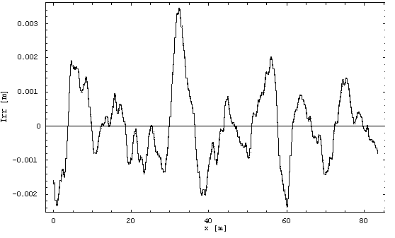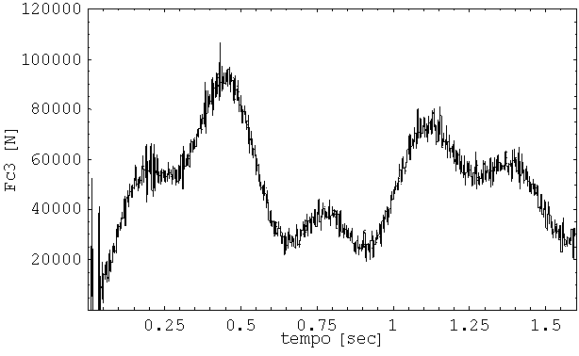

Static semi-
axle load
a) b)
Figure 9 – a) Vertical irregularity of the track (America Railway Standard – class 6 line ; b) wheel-rail contact force

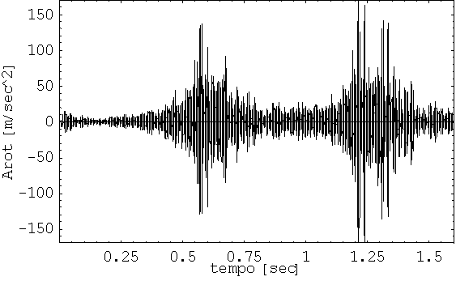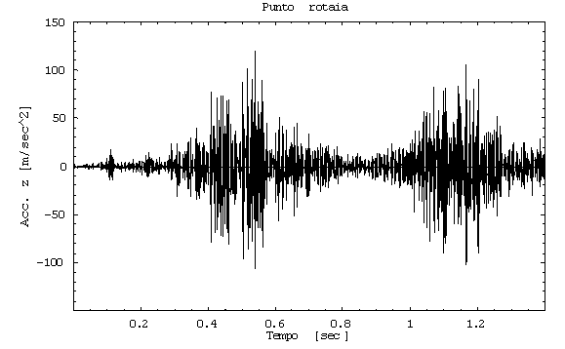
a) b)
Figure 10 – Vertical rail acceleration: a) numerical; b) experimental

In order to minimise the boundary effects as far as possible, the response of the system were calculated at the centre of the model.
Figure 9-b shows the time history of wheel-rail contact force; the transitory phase, lasting about 0,2 sec, is due to imposition of initial null conditions.
Figure 10 shows the time history of vertical rail acceleration, in both experimental and numerical terms, respectively; it may be seen the numerical and experimental values are essentially the same.
The vertical displacement of the rail is shown in figure 11; the maximum amount of displacement is found to be the same as that recorded in technical literature for analogous conditions (Accattatis F. et al.1991, Cioffi E. et al. 2003 ).

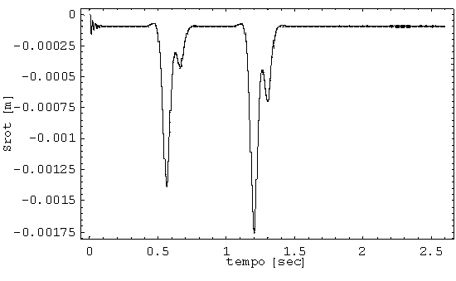
Figure 11 – Vertical displacement of the rail calculated numerically

Phase II – rail track-ground interaction
The 3D FEM model of the observed scenario was used with the ADINA code of calculation.
Figure 4 shows the model mesh, specifying the dimensions of the geometric domain in question; table 3 summarises the geometric and mechanical parameters used for the modelling of the rails and sleepers.

Table 3 - Geometric and mechanical characteristics of rail and sleeper
Rail type UIC 50
A [m²] | I_{xx} [m⁴] | I_{yy} [m⁴] | I_{xy} [m⁴]
0,00635 | 1,84×10⁻⁵ | 3,62×10⁻⁶ | 1,84×10⁻⁶
E [N/m²] | ρ [kg/m³] | ν | α | β
2,10×10¹¹ | 8750 | 0,25 | 7,352195 | 1,16514×10⁻⁵
FS Oak sleeper
l [m] | s [m] | h [m] | α | β
2,6 | 0,26 | 0,16 | α | β
E [N/m²] | ν | ρ [kg/m³] | 31,356083 | 7,356083×10⁻⁵
1,15×10¹⁰ | 0,3 | 1300 | 31,356083 | 7,356083×10⁻⁵

The parameters applied to the spring-damping element used for the modelling, in the case of wooden sleeper with K-fasteners, have the following stiffness and damping values, respectively: K=265 MN/m, C= 40000 N sec/m (Thompson D.J. et al. 1994, Thompson D.J. et al. 1997).
Regarding the ground, it has already been stated that this is made up of compact calcarenite mass, characterised by a density ρ=1800 kg/m³ and by a shear wave velocity V_{s}=700m/sec. The density and velocity of the S-waves define the shearing modulus for low deformations:

$G_{0}=ρ⋅V_{s}^{2}={\text{882 MN/m}}^{2}$. (Eq. 5)

The definition of calcarenite elastic properties was completed giving the Poison coefficient ν=0,3 and determining Young’s modulus E.

Table 4 - Mechanical characteristics of the ground and ballast
 | E  [N/m²] | ρ  [kg/m³] | ν | α | β
Ballast | 200×10⁶ | 1700 | 0,4 | 5,980952 | 3,03306×10⁻⁴
Calcarenite | 2293,2×10⁶ | 1800 | 0,3 | 0,60579 | 1,577662×10⁻⁵

Table 4 summarises the mechanical characteristics of the ground and ballast
In order to compare the numerical results with the experimental data, the response of the model in terms of the time history of the acceleration was calculated in the nodes that were in the same geometrical positions as those monitored on the site. The numerical and experimental results obtained are as follows

Rail track
As far as the rail point is concerned, there is a close similarity between the numerical calculation of the time history, and the experimental results obtained on the site (Fig. 12), supported by the substantial similarity in measured and calculated amplitudes.

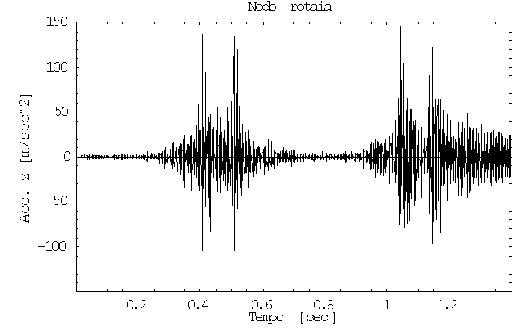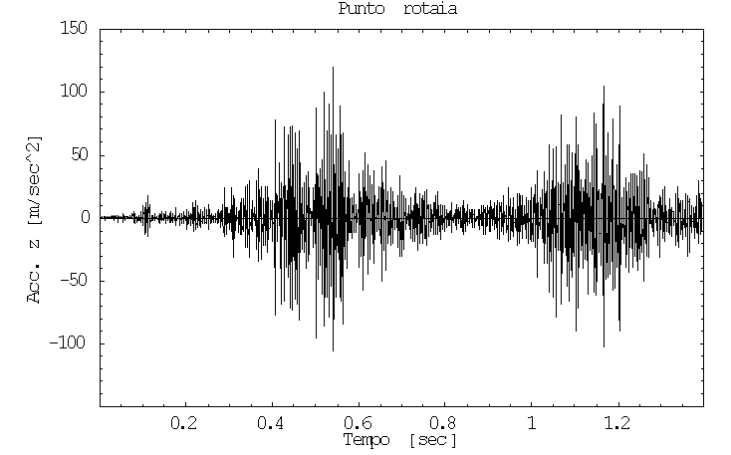
a) boundary effects b)
Figure 12 – Rail acceleration in z direction: a) numerical; b) experimental

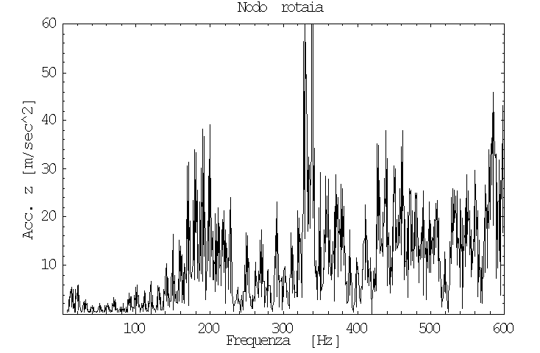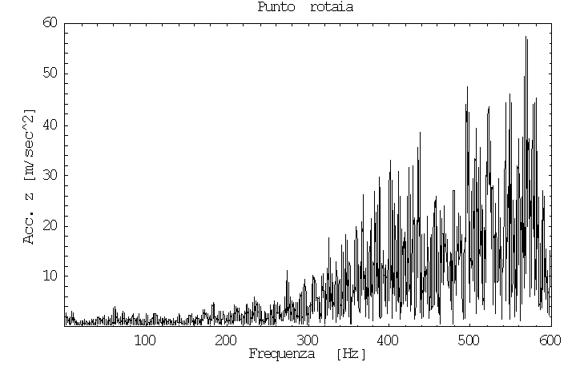
a) b)
Figure 13 – Frequency distribution of rail acceleration in z direction: a) numerical; b) experimental

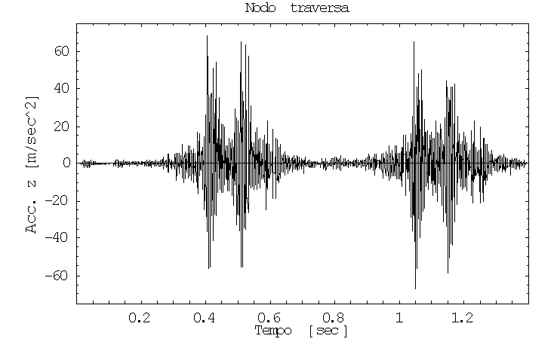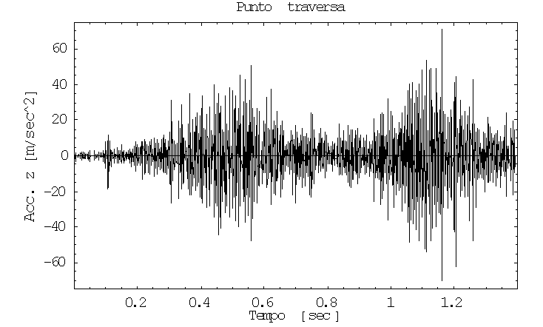
a) b)
Figure 14 – Sleeper acceleration in z direction: a) numerical; b) experimental

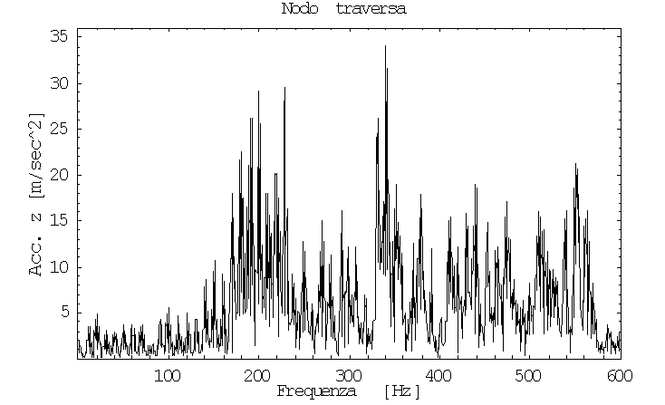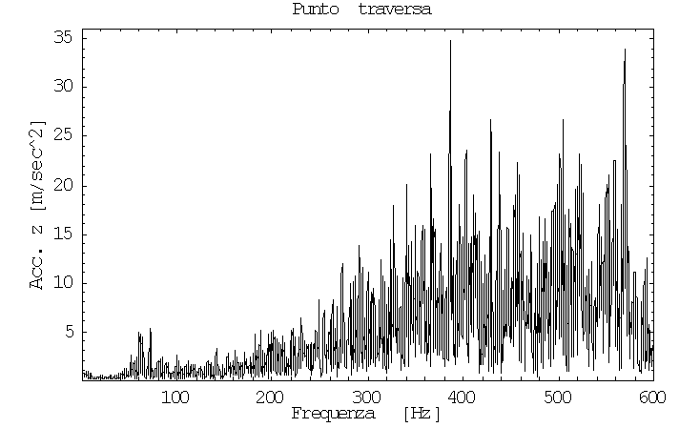
a) b)
Figure 15 – Frequency distribution of the sleeper acceleration in z direction: a) numerical; b) experimental

However, the spectrum shown in figure 13 highlight two areas of increase by 200 and 340 Hz, (Fig.13-a) that were not found experimentally (Fig. 13-b). This may be due to vertical irregularity in numerical simulations, which only partially reproduces the irregularities found in a railway line
The same observations may be made regarding the results of the sleeper point (Fig. 13 and 14).

Ground
Analysing the time history in y direction of ground point P₃ (Fig. 16), it may be seen how the numerical results essentially match the measurements carried out, reproducing the measured peaks fairly faithfully.

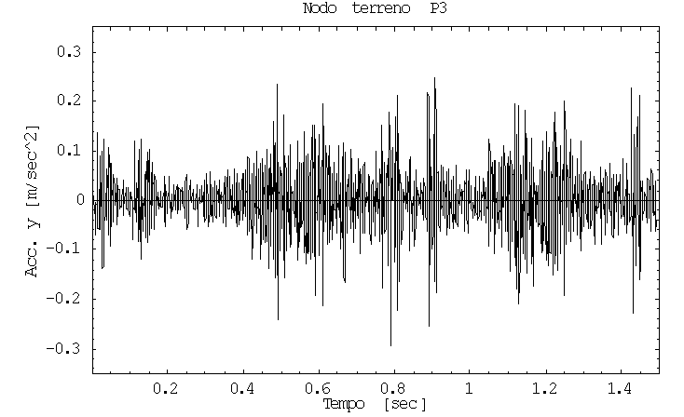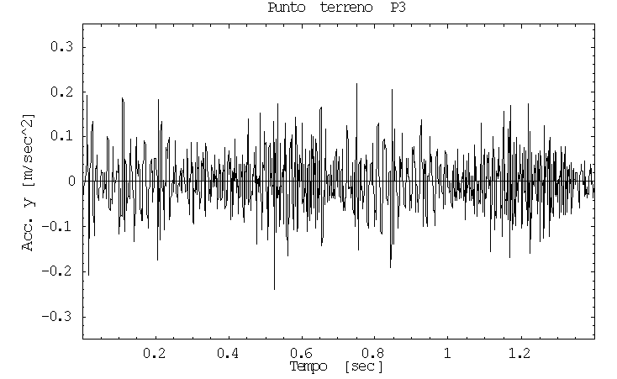
a) b)
Figure 16 – Acceleration in y direction at P₃ point: a) numerical; b) experimental

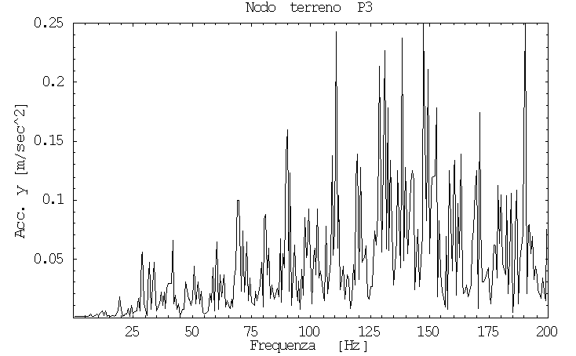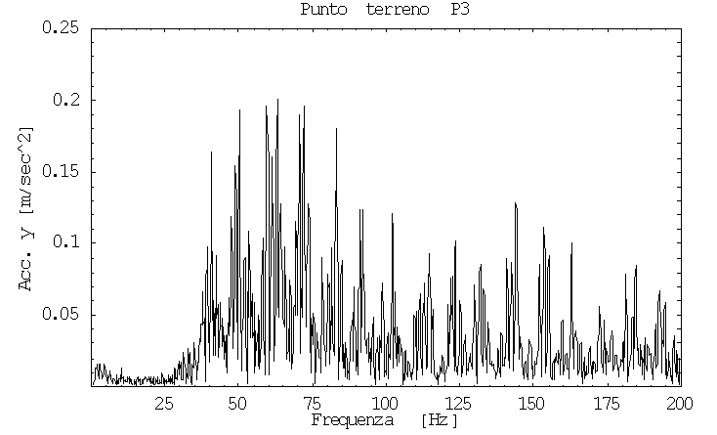
a) b)
Figure 17 – Frequency distribution of acceleration in y direction at P₃ point: a) numerical; b) experimental

On the other hand, an analysis of the spectrum (Fig. 17) shows some other aspects: the first regards the fact that the numerically simulated data does not faithfully reproduce the harmonics around a frequency of 60 Hz, where the experimental data showed maximum values of harmonics.
The two-dimensional model of the train-rail track interaction does not fully reproduce the typical stress of the wheelset-rail coupling which occur precisely at such frequencies.
A second aspect regards the fact that the frequency distributions of numerical accelerations show a consistent increase in vibrations at frequencies over 100 Hz, which is not found in experimental results. This is due to the vertical irregularity used to calculate contact force; vibrations produced exceeding 100 Hz, traceable in the numerical spectra for the rail and sleepers, are not adequately damped by the ballast and ground, due to the closeness between source and calculation point.
Similar observations may be made regarding acceleration in x direction; for reasons of brevity, these results are not included.
Regarding ground point P₄, as far as acceleration time history is concerned (Fig. 18), this case also shows close similarity between numerical and experimental data. In this case, also the frequency distribution of numerical data are essentially similar to the experimental results (Fig.19); it should be noted that the effect of increases exceeding 100 Hz, found previously in point P₃ is much reduced, due to the greater distance between source and observation point.

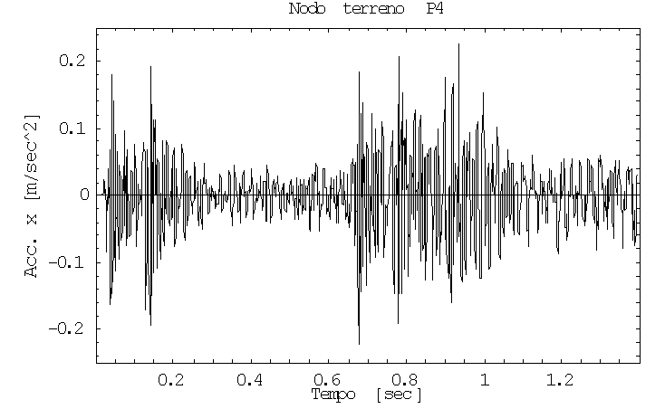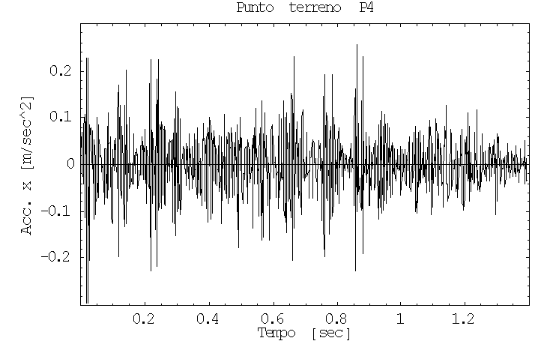
a) b)
Figure 18 – Acceleration in x direction at P₄ point: a) numerical; b) experimental

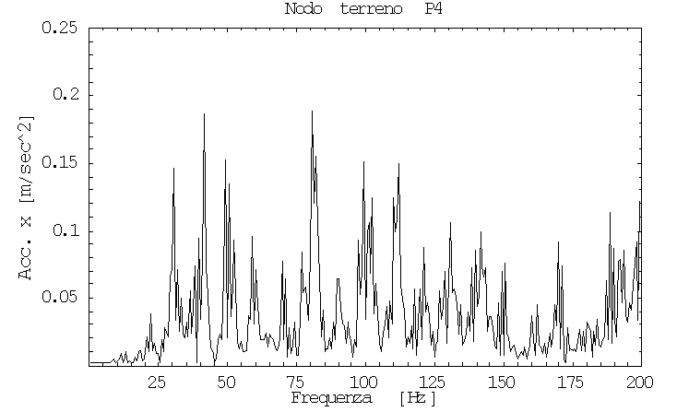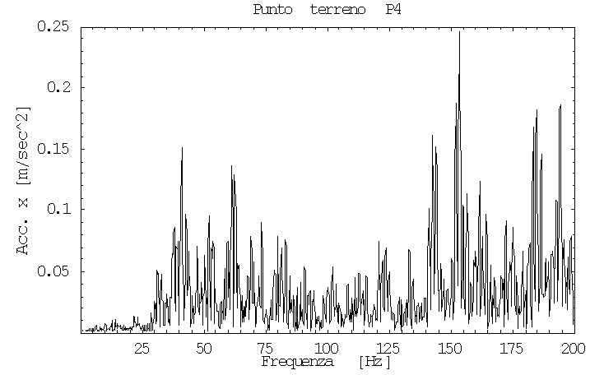
a) b)
Figure 19 – Frequency distribution of acceleration in x direction at P₄ point: a) numerical; b) experimental

CONCLUSIONS
The method of calculation proposed is validated by carrying out a series of measurements on site, with which it was possible to experimentally record the times of acceleration at selected points on the track and the surrounding ground during the passing of trains.
Analysing the results obtained, it may be deduced that, as far as wheel-rail interaction is concerned, numerical and experimental calculations of acceleration at the rail point are largely similar. Furthermore, the values of rail displacement are compatible with data found in technical literature for analogous conditions.
Regarding the other points observed, measured and calculated time histories were largely similar, which shows that the model is good at reproducing the generation and propagation mechanisms of vibration. However, regarding the elements of the rail track, spectral analysis of compared signals shows some divergence, which is essentially due to the typical spectrum of actual faults on a track, which may only partially be matched to those generated numerically. Furthermore, the 2D model for determining contact force does not adequately reproduce the low frequency interactions that are typical in wheel-set/rail-track contact. This incongruity is less and less noticeable as the distance from the source increases.
It is therefore possible to affirm that the method proposed appears to be reasonably adequate for the aims of quantifying ground-borne vibrations generated by railway transport. It may be useful in the planning phases of new railway stretches, as well in calculating the vibration pollution produced by stretches already in use.
Finally, where it is necessary to evaluate the possible success of mitigating interventions, and no suitable analysis is available, the forecasting nature of the procedure allows possible effects to be foreseen that might even be counter-productive.
REFERENCES
ACCATTATIS, F., COLLETTI, G., CORRIDORI, A., MALAVASI, G. (1991) – “Le vibrazioni dell’armamento ferroviario: considerazioni teoriche e verifiche sperimentali” – Ingegneria Ferroviaria, maggio, pp. 285-303.
CIOFFI, E., CORAZZA, R., KAJON, G. (2003) – “Caratteristiche e prestazioni degli armamamenti” – Ingegneria Ferroviaria, febbraio, pp. 121-133.
DI MINO, G., DI LIBERTO, C. M., NIGRELLI, J. (2007) – “A FEM model of rail track-ground system to calculate the ground borne vibrations: a case of rail track with wooden sleepers and k-fastenings at Castelvetrano” – Advanced Characterisation of Pavement and Soil Engineering Materials, 20-22 June, Athens, Greece.
KNOTHE, KL., GRASSIE, S. L. (1993) – “Modelling of railway track and vehicle/track interaction at high frequencies” – Vehicle system dynamics, 22 (1993), pp. 209-262.
LEI, X., NODA, N.-A. (2002) – “Analyses of dynamic response of vehicle and track coupling system with random irregularity of track vertical profile” – Journal of Sound and Vibration, 258, 1, pp. 147-165.
PANAGIN R. (1990) – “La dinamica del veicolo ferroviario” – Leprotto e bella, Torino.
ROBERTS, J. B., SPANOS, P. D. (1990) – “Random Vibration and Statistical Linearization” – John Wiley & Sons Ltd, New York.
SATO, Y., ODAKA, T. and TAKAI, H. (1987) – “Theoretical analysis on vibration of ballasted track” – Railway Technical Research Report No. 1347.
THOMPSON, D. J., VINCENT, N. (1994) – “Track dynamic behaviour rat at high frequencies. Part 1: theoretical models and laboratory measurements” – Vehicle system dynamics, 24 (1994), pp. 86-99
THOMPSON, D. J., VERHEIJ, J. W. (1997) – “The dynamic behaviour of rail fasteners at high frequencies” – Applied Acoustics, Vol. 52,1, pp. 1-17.
ZHAI, W. (1992) – “The vertical model of vehicle-track system and its coupling dynamics” – J. of the China Railway Society, 14, 3, pp. 21-29
ACKNOWLEDGMENTS
The authors would like to acknowledge the following agencies for their support to this research work: Rete Ferroviaria Italiana s.p.a. and Trenitalia s.p.a.. In particular we would like to acknowledge the engineers Belluccia A., Genna G. end Trapani G..

